Heuristic analysis

Runkun Miao

In this project, we implement several heuristic functions into A* search algorithm to plan three transporting cargo problems, and the initial states and goals has been shown in figure1.

A* search is one of the most popular search algorithm which sums up the cost of path from the starting nodes g(n) and the cheapest cost using heuristic function h(n), the numerical description has been shown below [1],

$$f\left(n\right)=g\left(n\right)+h\left(n\right)$$

Three heuristic functions have been implemented. H_1, ignore precondition, and level sum heuristic. H_1, technically, is not a heuristic function, but a default value function. Ignore precondition is to ignore any precondition and assume that every goal can be achieve in one action and calculate the minimum cost for achieving all the goals [2]. Level sum uses sub goal independent assumption that assume the cost of achieving goals independently and that of achieving goals together are the same [2]. Level sum sums the level costs of the goals in the planning graph.

By comparing the test result for each heuristic function (table 2), we can see that level sum has better performance in node expansions and new nodes searching. But usually it eats more computational power. Especially in problem 3. Where ignore precondition only costs 21 sec to find optimal solution, level sum search used up almost seven minutes to provide the result. However, the number of expansions, goal tests and new nodes are largely decreased using level sum search. During more discrete problems with more goals, we may expect level sum heuristic will outperform ignore precondition heuristic [2].

Apart from a* search algorithm, we also ran some tests with breath first search, depth first search and uniform cost search. Comparing with A* search, those two searches except depth first search has enormous node expansion, but depth first search always fails to find optimal solution, so applying such heuristic function is implausible. Between breath first search and uniform cost search, uniform cost search has better speed advantage. In problem 3, uniform cost search only spent 86 sec compare 169 sec from breath first search, but with more node expansion.

Overall, among those six searches algorithm. A* with ignore precondition has the best run time performance, but in terms of node expansion and new nodes creation, A* with level sum is the best.

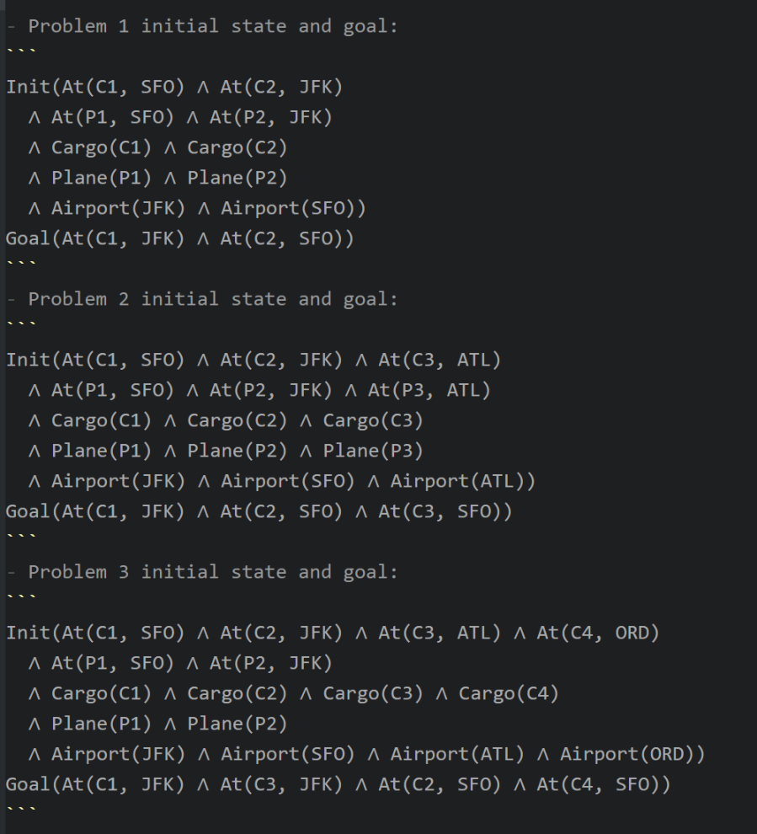

Figure 1

|  |  |  |  |  |  |  |
| --- | --- | --- | --- | --- | --- | --- |
|  |  | Expansions | Goal Tests | New Nodes | Time elapse | Time |

|  |  |  |  |  |  |  |
| --- | --- | --- | --- | --- | --- | --- |
| Q1 | breath first search | 43 | 56 | 180 | 6 | 0.038504 |
| depth first search graph search | 12 | 13 | 48 | 12 | 0.010376 |
| uniform cost search | 55 | 57 | 224 | 6 | 0.04504 |
| A* H_1 | 55 | 57 | 224 | 6 | 0.071688 |
| A* ignore precondition | 41 | 43 | 170 | 6 | 0.044314 |
| A* levelsum | 11 | 13 | 50 | 6 | 0.831946 |
| Load(C1, P1, SFO)  Fly(P1, SFO, JFK)  Unload(C1, P1, JFK)  Load(C2, P2, JFK)  Fly(P2, JFK, SFO)  Unload(C2, P2, SFO) | | | | | |
| Q2 | breath first search | 3343 | 4609 | 30509 | 9 | 17.5047 |
| depth first search graph search | 582 | 583 | 5211 | 575 | 3.92515 |
| uniform cost search | 4853 | 4855 | 44041 | 9 | 15.06033 |
| A* H_1 | 4853 | 4855 | 44041 | 9 | 17.33593 |
| A* ignore precondition | 1450 | 1452 | 13303 | 9 | 5.350824 |
| A* levelsum | 86 | 88 | 841 | 9 | 74.83001 |
| Load(C3, P3, ATL)  Fly(P3, ATL, SFO)  Unload(C3, P3, SFO)  Load(C1, P1, SFO)  Fly(P1, SFO, JFK)  Unload(C1, P1, JFK)  Load(C2, P2, JFK)  Fly(P2, JFK, SFO)  Unload(C2, P2, SFO) | | | | | |
| Q3 | breath first search | 14663 | 18098 | 129631 | 12 | 169.9418 |
| depth first search graph search | 1501 | 1502 | 12519 | 1451 | 21.6696 |
| uniform cost search | 18234 | 18236 | 159707 | 12 | 85.80248 |
| A* H_1 | 18234 | 18236 | 159707 | 12 | 67.24391 |
| A* ignore precondition | 5040 | 5042 | 44944 | 12 | 20.85351 |
| A* levelsum | 318 | 320 | 2934 | 12 | 413.1922 |
| Load(C2, P2, JFK)  Fly(P2, JFK, ORD)  Load(C4, P2, ORD)  Fly(P2, ORD, SFO)  Unload(C4, P2, SFO)  Load(C1, P1, SFO)  Fly(P1, SFO, ATL)  Load(C3, P1, ATL)  Fly(P1, ATL, JFK)  Unload(C3, P1, JFK)  Unload(C1, P1, JFK)  Unload(C2, P2, SFO) | | | | | |

Table 1

# References

|  |  |
| --- | --- |
| [1] | “A* search algorithm,” Wikipedia, [Online]. Available: https://en.wikipedia.org/wiki/A*_search_algorithm. |
| [2] | S. J. Russell and P. Norvig, “classical planning,” in *Artificial Intelligence Amodern Approach (3rd edition)*. |